Mehmet Izol

Professor Cleveland

COMP 3324-1 Computer Networks

Week 4 – Lab 2 – Hash Collisions

February, 28, 2023

Hash Collisions

Downloading and running Hello.exe and Erase.exe

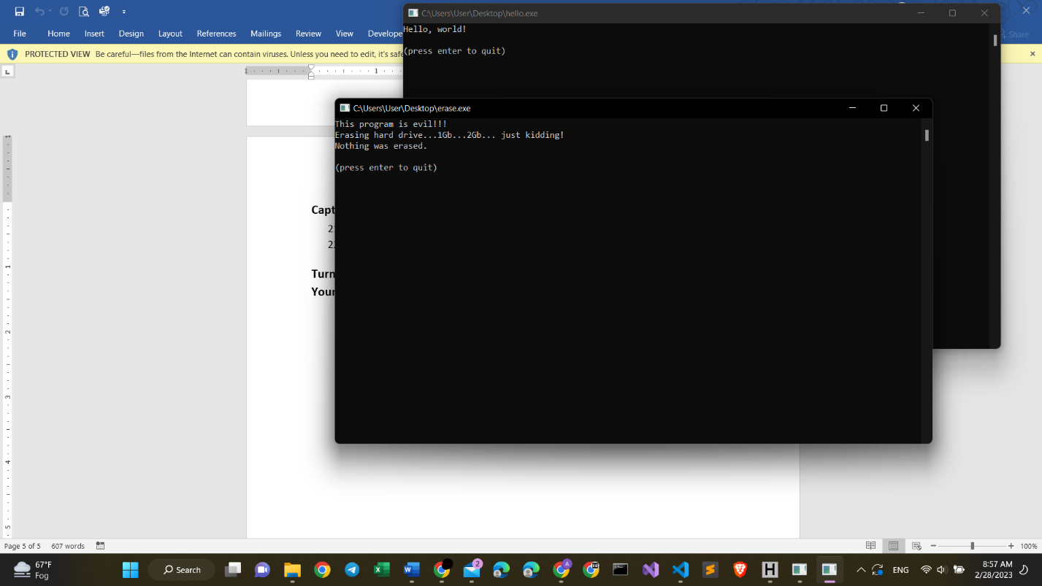

Proj 2a Mehmet Izol

Using Hash Calc

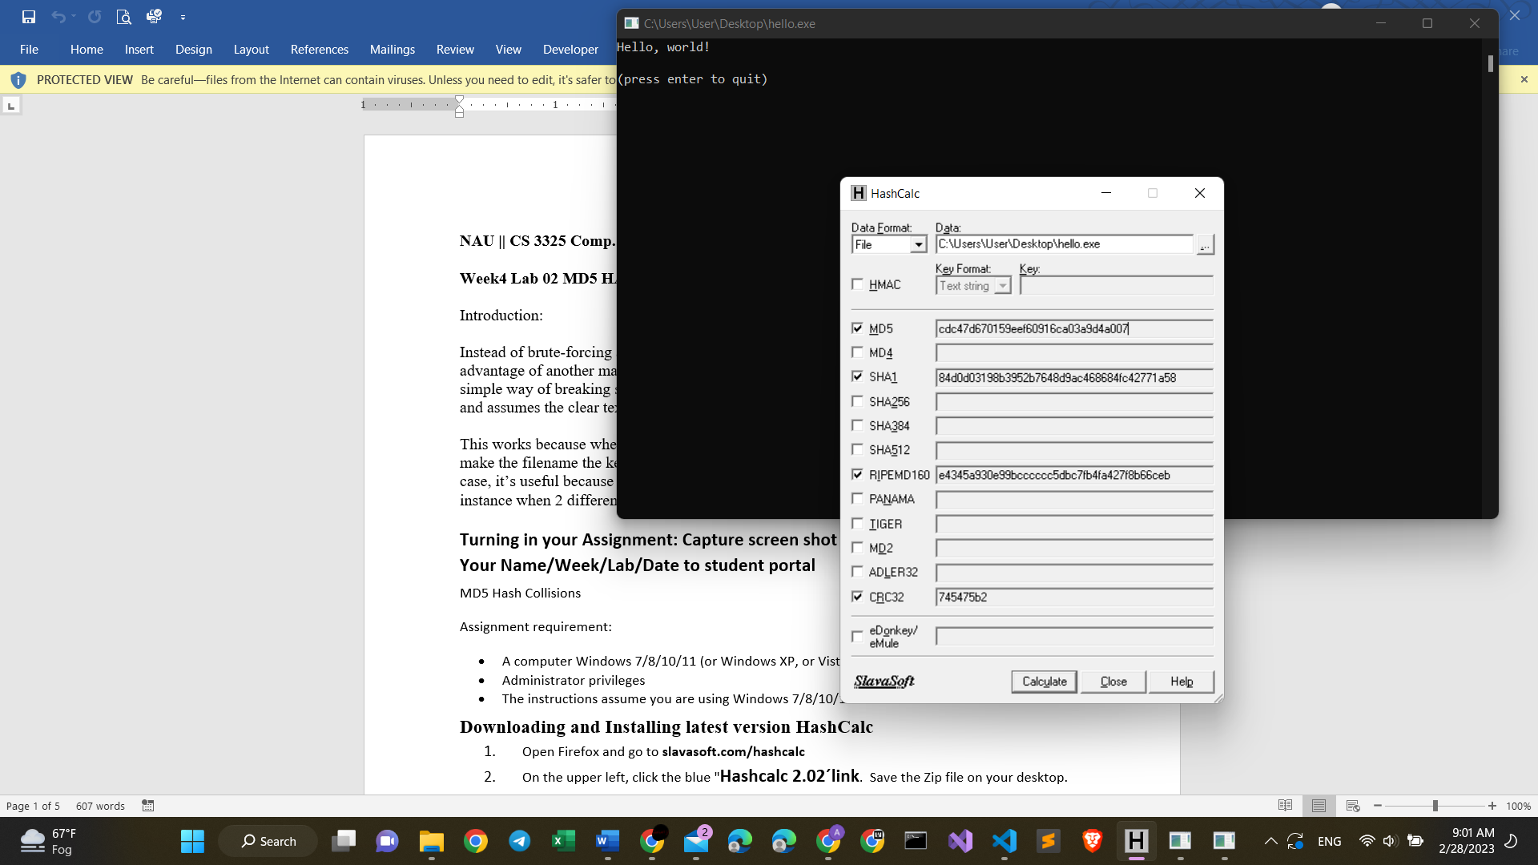

Proj 2b Mehmet Izol – hello.exe

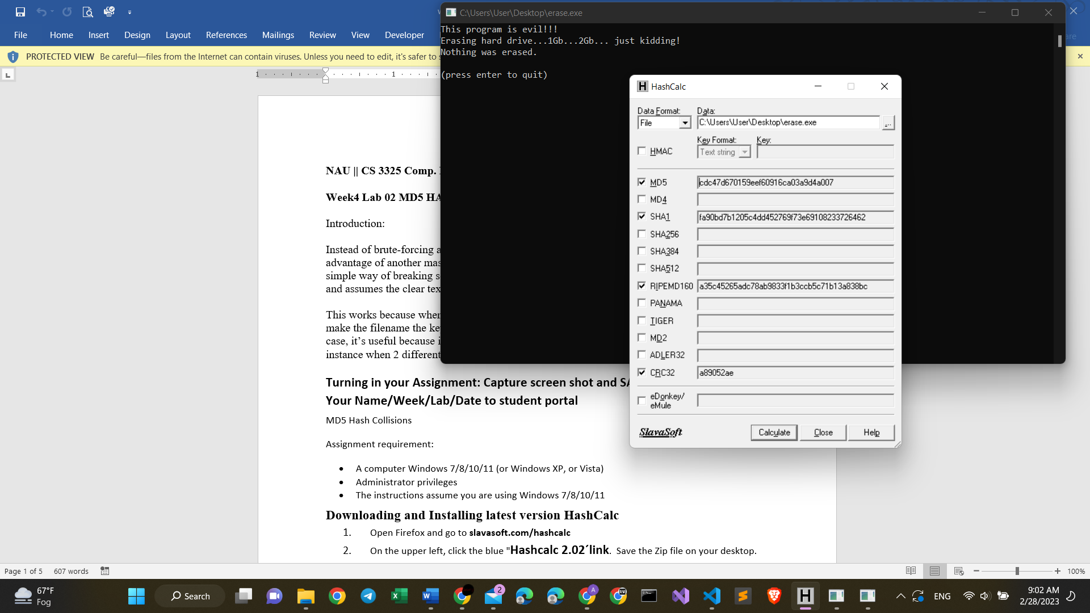

Proj 2b Mehmet Izol – erase.exe

What new I learned from this Hash Collisions Project

+ hash collision happens when two files, information, data have the same hash-value, i.e. MD5.

+ In the example above, we see that both hello.exe and erase.exe have the same MD5 value, ending with 007.

+ This task did not cause any trouble, and It was very easy to do.